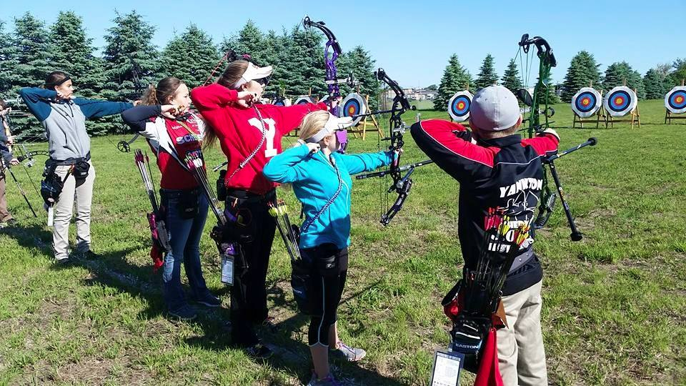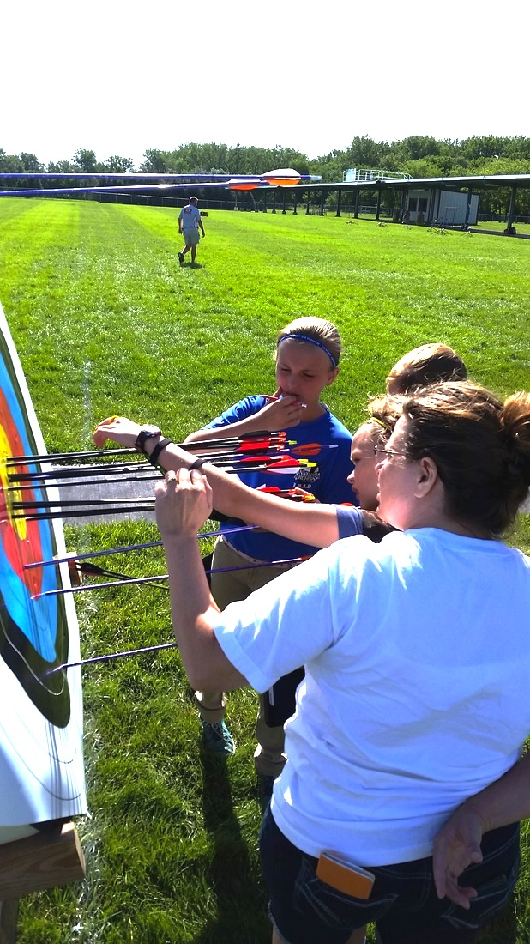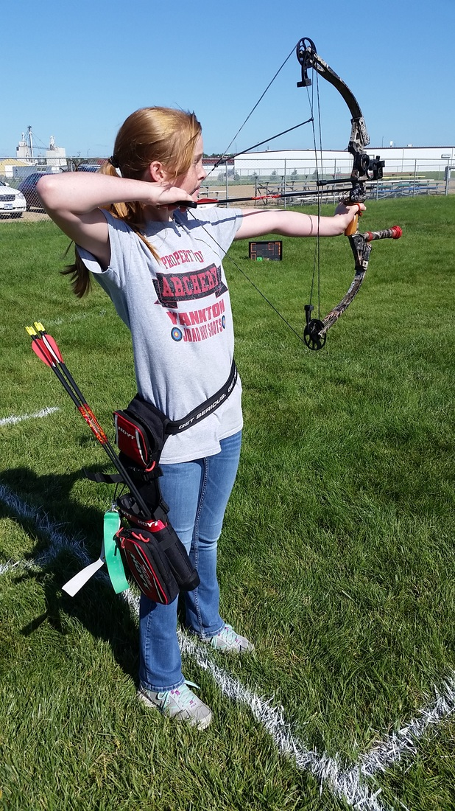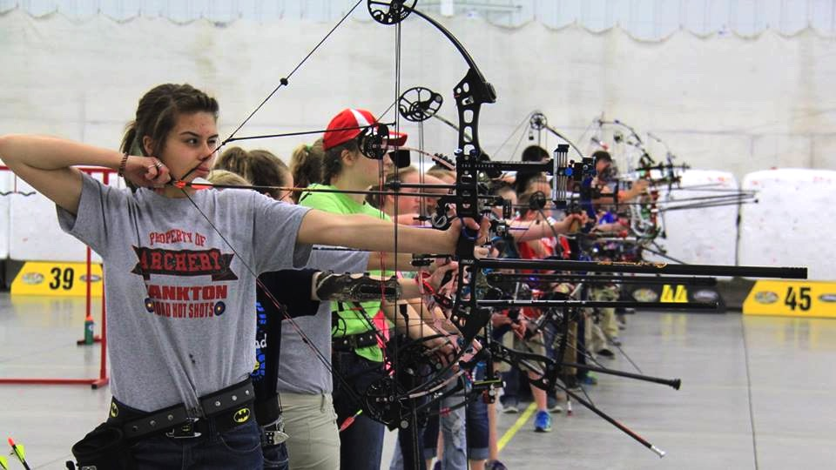

If anyone in your family hasn’t had archery training the Archery Center offers beginner’s classes every Saturday.

TRY Archery

Saturdays at 11 am

$5 per person

*“Archery is a sport anyone can participate in. It’s a great way for families to share a common hobby. We love archery and we want to share our passion for the sport and the good it does to everyone.”*

#### A family-friendly sport!

Follow us on Facebook

We meet and host events at the

NFAA Easton Yankton Archery Center

800 Archery Lane

Yankton, SD 57078

neyac.org

Visit out website for more information:

yanktonhotshots.org

Email us:

yanktonjoadhotshots@gmail.com

Yankton Hotshots Archery Club

🙞 🙜

### Join the fun!

🙞 🙜

Adult and J.O.A.D Club

# Try Archery

## Have questions?

## Get in touch!

I’m in a member of the Easton Yankton Archery Center, am I a Hotshots member?

In short, no. The Hotshots are a separate organization than the center and any range membership or classes at the center are separate from the Hot Shots.

What are the benefits of joining the club?

In addition to pin shoots, the club also organizes fundraising events as well as fun social events for archers in the area.

What are pin shoots?

Pin shoots are like mini tournaments where archers can shoot in tournament-like settings that earn an archer achievement pins based on their scores.

Do you host anything other than pin shoots?

Absolutely, aside from the popular pin shoots the Hotshots often host fundraising events for the purpose of helping archers raise money for their archery needs such as equipment and tournament costs.

For more info visit out website.

The Yankton Hotshots is an archery club recognized by USA Archery as both and adult and JOAD (Junior Olympic Archery Development) club. The mission of the club is to provide support for youth and adult archers in the Yankton area and across South Dakota. The club meets and hosts tournaments at the NFAA Easton Yankton Archery Center for members of this club and is open to all non-member archers as well. The club is recognized as a 501c non-profit organization.

The Hotshots encourage archers to develop their skills through classes and archery events as well as promote the spirit of teamwork and sportsmanship to create lifelong friendships through the sport of archery.

The most common events the club hosts are pin shoots which take place every other month during fall and winter months and once a month during spring and summer months.

# We are the Yankton Hotshots Archery Club

## FAQ